CRPO Grant Call Proposal Template

Proposal No.: <To be completed by CRPO>

Proposals under the research grant calls are encouraged to at least have a collaboration with industry (either in kind/cash or both in kind & cash collaboration).

Proposals should be submitted to the grantor through the Host Institution’s POC and CRPO should receive them no later than the given deadline 18 February 2024, 5:00pm. Host Institution refers to the Lead PI’s institution.
Late or incomplete submissions will not be accepted.

Please duly complete all sections in this form:
Section 1: PARTICULARS OF LEAD PRINCIPAL INVESTIGATOR (PI)
Section 2: PARTICULARS OF CO-PI(S) (if applicable)
Section 3: PARTICULARS OF INDUSTRY COLLABORATOR(S) (if applicable)
Section 4: RESEARCH (not to exceed 10 pages, Text to be in Arial font 11 pt, single spacing)
Section 5: SCHEDULE
Section 6: SUMMARY OF PROJECT BUDGET (CRPO GRANT REQUEST)
Section 7: DECLARATIONS
Section 8: INSTITUTIONAL SUPPORT
Annex 1: CURRICULUM VITAE
Annex 2: DECLARATION OF OTHER FUNDING SUPPORT SUPPLEMENTARY

Section 1: PARTICULARS OF LEAD PRINCIPAL INVESTIGATOR (PI)

Name of Lead PI:
Current Designation
(full-time appointment only):
Department / Division & Faculty / School, University / Organisation:
Email Address:
ORCID ID:
% of Time Committed

Section 2: PARTICULARS OF CO-PI(S):
(insert rows for this section if more than one co-PI)

Name of Co-PI:
Current Designation
(full-time appointment only):
Department / Division & Faculty / School, University / Organisation:
Email Address:
ORCID ID:
% of Time Committed¹

Section 3: PARTICULARS OF ACADEMIC/INDUSTRY COLLABORATOR(S):
(if any, insert rows for this section if more than one collaborator)

Name of Organisation
(must provide a letter of commitment from industry partners):
Contact Name:
Title & Department:
Email Address:
ORCID ID:
Registered Organisation Address:
Primary Business Address
(if different from Registered Address):
Organisation Type³: | MNC/LLE/SME
Business Commencement Year³:
UEN^{3:}
% of Time Committed¹:

Section 4: RESEARCH

(Please use separate sheet(s) if the space is insufficient)
The total number of pages for this section shall not be more than 10 pages in total (Text to be in Arial 11-point font, single spacing). Diagrams, references and Gantt chart should be attached as appendices, excluded from the page limits. Elaboration of the proposal’s contents within appendices will not be reviewed.

PROJECT TITLE:
KEY OBJECTIVES AND DESCRIPTION OF PROPOSED PROJECT

- List key objectives of the proposal and how it aligns to CRPO’s objectives and direction
- Briefly describe:
  - The novelty of the research (i.e how the approach differentiates and sets it apart from others in the same field
  - The needle-moving research challenge that the proposal will solve.

SIGNIFICANCE AND POTENTIAL IMPACT OF PROJECT:

Describe how this project will contribute and value-add <Topics of Research> and elaborate the benefit/impact of the project to the relevance to Singapore.

TECHNICAL DESCRIPTION:

The description should include the following:
- Details of techniques and data used and how they will achieve the stated objectives.
- Challenges, risks and proposed mitigation plans.
- Competitors/people working in similar areas that the applicant is aware of.

IMPLEMENTATION PLAN:

Briefly describe team member(s)’ contribution to the programme and the plans for interaction among the team member(s) in achieving the research objectives.

INDUSTRY IMPACT:

Describe the potential industry application this project would have, and the potential impact it would have in growing existing industry activities or attracting new industry sectors that will generate value for Singapore.

Project Support and Facilitation:

If applicable, quantify and justify the need of resources from CRPO. The requests should be aligned with current research focus of CRPO. Due to the constraints of limited resources, CRPO reserves the right to turn down the request.

Section 4.1: Team Structure

  - One Lead-PI from Singapore-based Institutes of Higher Learning (IHLs) and Research Institutes (RIs) to conduct fundamental research.

  - One industry Co-PI from Singapore-based companies to identify and translate IPs with commercial potential.

  - Potential customer collaborators who are willing to adopt the developed security solutions and provide requirement feedback.

  - An illustration of the team structure and the collaboration between the teams is shown below:
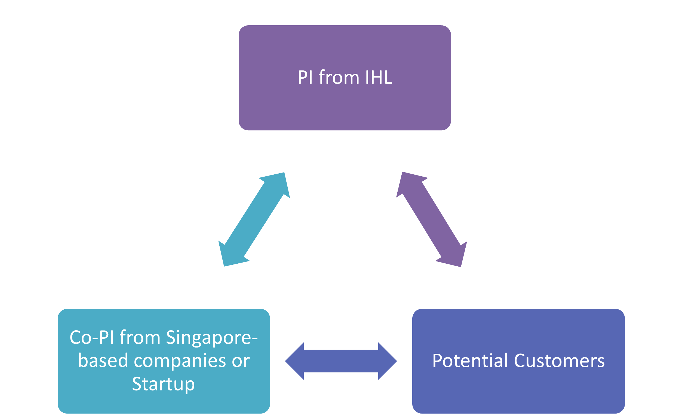

Section 5: SCHEDULE

Estimated Start Date: dd-mmm-yy Eg. 01-Dec-23
Estimated Completion Date: dd-mmm-yy

Please create a timeline and shade the boxes for each milestone accordingly
(add/remove rows where necessary).
(5.1) Research Milestones / Deliverables | Year 1 | Year 2 | Year 3
Milestone 1: <description>
Milestone 2: <description>
Milestone 3: <description>
Milestone 4: <description>
Milestone 5: <description>
Milestone 6: <description>

(5.2) Key Performance Indicators (KPIs)
S/N | Category | Items | Proposed Target  (“0” if N/A)
1 | Research  Excellence | No. of CRPO related topics publications in top 10% journals  *This measures the number of publications in the top 10% of journals in related field as tracked in the Clarivate Analytics Journal Citation Report.
2 | Manpower | No. of Industry R&D Jobs (Tracked by SG/PR/Foreigner Breakdown)  *This measures the number of industry R&D jobs induced in the ecosystem by public R&D investments. This KPI counts the job roles/positions created by companies in the private sector. The project managers, product designers, technicians are considered non-RSE (Research, Scientist, Engineer) jobs, but are counted under industry R&D jobs.
3 | Manpower | No. of PhDs and Masters trained through the CRPO Research Grant Call  *This measures the number of students participating in the project.
4 | I&E | No. of Technologies Deployed, including Licenses  *This measures the number of research findings or technologies developed that are deployed (e.g. through a license or deployment at an actual site) that will contribute to at least one of the following outcomes:  (i) Introduction of new product in the market;  (ii) Introduction of new service in the market;  (iii) product or process improvement.
5 | <insert rows to add other KPIs where applicable>

Section 6: SUMMARY OF PROJECT BUDGET (CRPO GRANT REQUEST)

Item | S$
Expenditure on Manpower (EOM):
Other Operating Expenses (OOE):
Equipment (EQPT):
Overseas Travel (OT):
Total Direct Costs
Prevailing Indirect Research Costs (IRC)
Total Grant Requested
BREAKDOWN OF PROJECT BUDGET
Please include GST, where applicable
(6.1) EOM
Projections should include salary and costs of all other remunerative benefits (e.g. employer cpf, etc)
Designation | Qty | Cost | Total Cost
Sub-total
(6.2) OOE
Item Description (include justifications) | Qty | Cost | Total Cost
Sub-total
(6.3) EQPT
Written quotations should be appended for equipment with value >$100,000 requested. State whether similar equipment exists in the PI’s/Co-PIs’ labs or department/school. If so, justify why a new equipment is required for the project
Item Description (include justifications) | Qty | Cost | Total Cost
Sub-total
(6.4) OT
Item Description (include justifications) | Qty | Cost | Total Cost
Sub-total

6.5 Funding for the project provided by Company

CONTRIBUTION BY COMPANY
(6.51) EOM
Numbers & Staff Category | Cash | In-kind
e.g. 1x Research Fellow
e.g. 1x PhD
e.g. 1x Research Assistant
Others
Sub-total
(6.52) OOE
Item Description | Cash | In-kind
Sub-total
(6.53) EQPT
Item Description | Cash | In-kind
Sub-total
(6.54) OT
Item Description (include justifications) | Cash | In-kind
Sub-total
(6.55) IRC to Host Institution
Total Contribution by Company

Section 7: DECLARATIONS

(A) Conflict of Interest- Lead Principal Investigator (PI), Co-PI(s), and/or Industry Collaborator(s) are Committee Members of the CRPO: Yes/No (please delete accordingly)

If the answer to the above is “Yes”, please complete the following:
I hereby declare that I am a Committee Member of the CRPO (please delete if applicable) and understand that I will have to recuse myself from the evaluation of this proposal.

----------------------------------------- ------------------------------------
Name and Signature Date

(B) Our project involves the use of (please shade box if applicable)
Human Subjects
Vertebrate Animals
The appropriate ethical clearance from the following committee has been obtained to proceed with this project if it were supported:

Name of Ethics Committee:

(C) Please provide following details if you (PI and all Co-PIs listed on Section 1 and 2, not required for Collaborators) have been awarded / intend to send similar research proposals for this application to other funding agencies. These include those supported by and/or applied to universities, other public funding agencies and foundations. Note that all PI and Co-PIs must be accounted for under this section.

S/N | Project Title | Funding Agency | Status (Submitted / Awarded) | Amount applied for / awarded (S$) | If “Awarded”, indicate name of PI/Co-PI awarded

If any of the currently held grants above fund research topics related to the CRPO proposal, please include a one-page supplementary write-up as an annex (Template found in Annex 2). The one-page supplementary write-up is to describe the research funded by these grants, and how the objectives and research differ from that in the CRPO proposal.

(D) By signing this Grant Application, the Lead Principal Investigator (PI), all Co-Principal Investigator(s) (Co-PIs) and industry collaborators undertake and agree to:
- Allow CRPO to collect, use and disclose your personal data, as provided on this proposal for the purposes of evaluating the capabilities of the proposed research team. If you are providing someone else’s personal data, you hereby declare that you have obtained consent from the named individual(s) in this proposal, for the collection, use and disclosure of his/her personal data by CRPO for the above stated purposes.
- Ensure that the requested manpower, equipment and/or resources are not being funded by another source.
- Not send similar versions or part(s) of this proposal to other agencies for funding.
- Submit supporting documents of ethics approval obtained from the relevant Institutional Review Board (IRB) and Animal Care and Use Committee for studies involving human subjects / human tissues or cells, and animal / animal tissues or cells respectively.
- Comply with the provisions of any relevant laws of the Republic of Singapore, statutes, regulations, by-laws, rules, guidelines and requirements applicable to it, as well as all applicable policies and procedures adopted by CRPO and/or CSA and /or NRF as the same may be amended or varied from time to time.
- Agree to hold primary responsibility for the responsible conduct of research, and shall abide and comply with the ethical, legal and professional standards relevant to research, in accordance to the research integrity policy of the Host Institution.

We declare that the facts stated in this application and the accompanying information are true. This is an original and latest version of the proposal. We also declare that no other versions of this proposal (or parts thereof) with similar objectives, scope, deliverables or outcomes have been or will be submitted to any other funding bodies.

Name of Applicant(s) | Signature | Date Signed
Lead Principal Investigator (PI):
<Name of Applicant>

Co-Principal Investigator 1 (Co-PI 1):
<Name of Applicant>

Collaborator 1 (if applicable):
<Name of Applicant>

Insert/delete rows above as necessary.

Section 8: INSTITUTIONAL SUPPORT

To be completed by the Principal / Director of the respective office of research / academic institute (or equivalent) of the Lead PI.

By signing the Grant Application, the Host Institution undertakes and agrees to:
- Confirm the accuracy and completeness of the information submitted.
- Ensure that the applicant is independently salaried by the institution for the entire period of the grant.
- Ensure that the budget is appropriate and reasonable (e.g., no double funding/excessive purchase of equipment), and is aligned with the Host Institution’s HR and other policies.
- Ensure that the proposed research will be conducted in the Host Institution.
- Provide adequate resources to the applicant for the entire grant period (e.g., lab spaces, mentorship and career development support).
- Ensure that the funds provided are used for appropriate purposes.
- Ensure that the study complies with all laws, rules and regulations pertaining to national and the institution’s research operating procedures and guidelines.

Name:
Designation: |  | Institution:
Signature: |  | Date:

ANNEX 1: CURRICULUM VITAE

Please use the format below to provide the required information on PI and Co-I(s). Indicate NA if the required information is not applicable. Each CV should not exceed 2 pages.

- Name
- Age
- Office Mailing Address
- Email
- Contact No (Office No.)
- Current position and past employment history
- Order details in reverse chronological order
- Provide full details, e.g., joint appointments; other academic appointments including those outside of Singapore
- Provide duration of appointment, type of appointment, the research topic, the institute and the research supervisor, if applicable.
- Academic qualifications
- Please indicate institution’s name and the date of awarded degree
- Research interests
- Publications in the last 3 years
- Include only publications of direct relevance to proposal research area, stating impact factors where available
- Please emphasise your name in bold
- Patents held (related or unrelated to study)
- Scientific awards
- For PI only. Percentage of time spent in Singapore every year (% declared should exclude only time spent overseas due to overseas appointment(s). Please indicate reason(s) if % declared is less than 100%).

ANNEX 2: DECLARATION OF OTHER FUNDING SUPPORT SUPPLEMENTARY

Please note the eligibility requirements:

PI and Co-PIs should note that parallel submissions are not allowed – i.e. applicants must never send similar versions or part(s) of the current proposal application to other agencies or grants for funding (or vice versa).

S/N | The serial number should correspond with the proposal declared in Section 7 (C)
Title of Supported Project

Project start and end date (d-mmm-yy)
Description | It should cover:  - Description of the research funded by other awarded/applied grant.  - How the objectives and research differ from the proposal submitting to CRPO.

-End of Proposal Form-

1 Represents % of time spent by the PI/Co-PI/Collaborator on the project relative to his/her other job scopes Field applicable to Academic Collaborator only 3 Fields applicable to Industry Collaborator only

