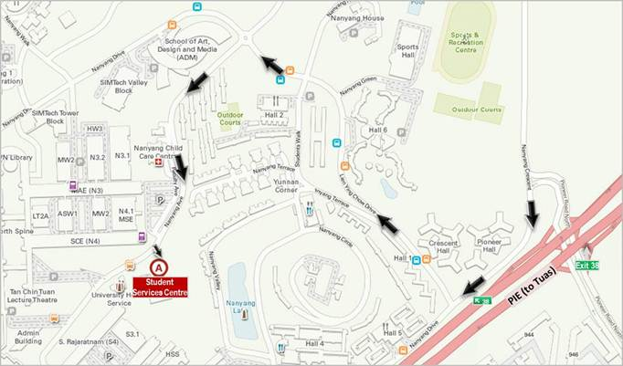
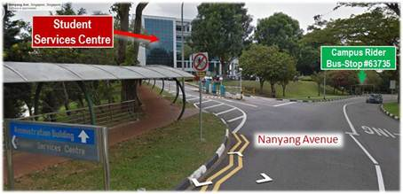 | NTU Shared Services (NSS)  Nanyang Technological University  Level 5  Student Services Centre (SSC)  42 Nanyang Avenue  Singapore 639815
Driving Directions to Student Services Centre (SSC) in NTU Campus
- Head north on PIE toward Tuas
- Take Exit 38 for Pioneer Road North
- Turn left into Nanyang Crescent
- Turn right into Lien Ying Chow Drive
- At roundabout, turn left (9 o’clock turn) to Nanyang Avenue
- At 460m, turn left into Gentry of Carpark G
- Park your vehicle at only the white lots in Carpark G
- Enter foyer of SSC, and take lift to Level 5

If you are using public transport –
- Board the train (East-West Line) towards Joo Koon, and alight at Pioneer Station
- Walk 38m, take the Exit on your right and walk to the bus stop below the MRT station
- Board the Campus Rider (free bus service commuting between Pioneer MRT and NTU campus)
- Alight at bus-stop #63735 outside SSC at Nanyang Avenue
- Walk about 120m along the pedestrian footpath to SSC
- Enter foyer of SSC, and take lift to Level 5

