Abstract Title for the 12th Asian Symposium on Intense Laser Science (ASILS12)

Adam AuthorA,¹ Brenda AuthorB,² ..... , Daniel Author^{1*}
¹ First author's affiliation, Address, Country
² Second author's affiliation, Address, Country
Corresponding author: daniel.author@abc.edu.sg

Please submit the abstract in Microsoft Word format (*.docx), naming the file “Lastname Firstname.docx” after the presenting author. The length of the abstract should be limited to one page, including figures. Please either follow the format and style described below or directly enter the text into the template.
The abstract should be typed in A4-page format (8.27” × 11.69”), leaving all margins at 1”. Do not add a page number or abstract number to the abstract.
The font for the title is 12-point Times New Roman. Please use title case and center-align the text. Leave a blank line after the title.
The font for the remaining text is 10-point Times New Roman and the paragraph style is 1.3 multiple line-spaced, with a spacing of 3 points after each paragraph. Authors’ names (center aligned) are written with given name followed by family name, e.g., Adam Author. Multiple authors are separated by commas. If the authors have different affiliations, a number in superscript following each name can be inserted. Please mark the corresponding author with a superscript “*” and underline the presenting author’s name. Please provide the email address of the corresponding author. Leave one blank line before starting the main text of the abstract. Use the justify alignment for the paragraph of the main text. Please integrate figures within the main text (Fig. 1). The figures should have sufficient line thickness and sufficiently high resolution.
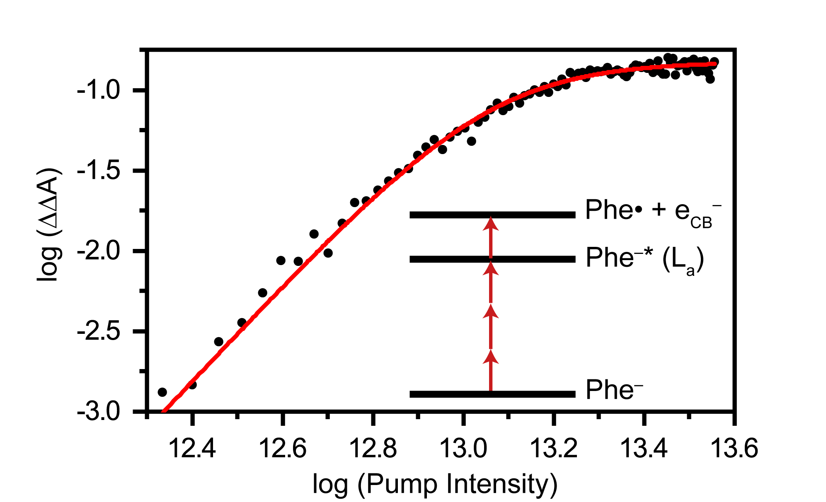
Fig. 1. Log-log plot of the differential absorption signal vs. pump intensity.
Acknowledgement may be included at the end of main text.
References (optional) should be indicated in the text in square brackets [1] and listed at the end of the abstract, using 9-point font size, with an indent of 7.5 mm, and following APS style.

Acknowledgement Financial support from … are acknowledged.

References
- J. M. Smith, R. Brown, C. Green, D. Jones, and A. Lee, Phys. Rev. B 46, 1 (1992).
- J. M. Smith, in Molecular Dynamics, edited by C. Brown (Academic, New York, 1980).
- J. M. Smith, Molecular Dynamics (Academic, New York, 1980), Vol. 2, p. 20.

