Self-Registration Guide for Wireless SSID - ‘NIE Guest’

- Connect your device to Wi-Fi via ‘NIE Guest’.

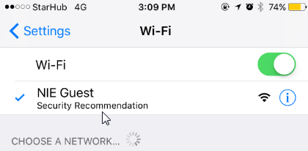

- A pop-up window will show up, prompting for user login.
- If you already have user credentials, enter your username and password. Otherwise, go to step 2(b).
- Click ‘Sign On’.
- Click ‘Accept’ after reading the Acceptable Use Policy.
- Once connected, you will be redirected to a NIE feedback website.

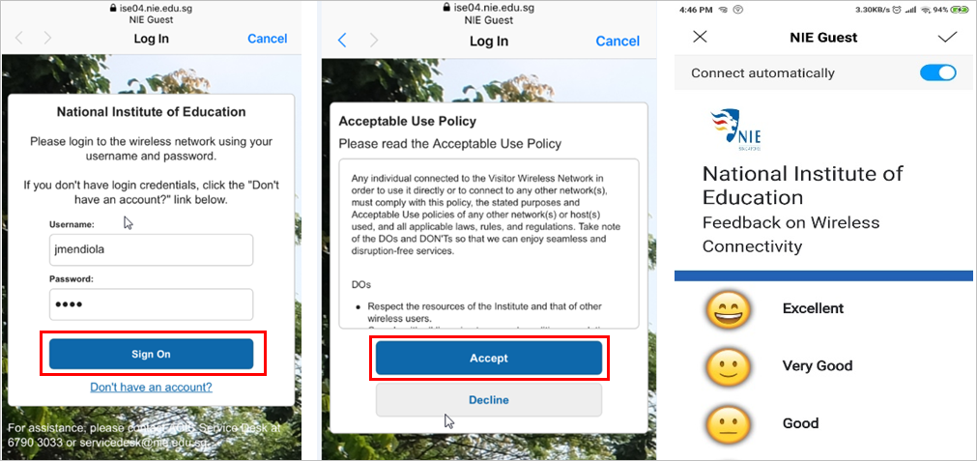

- If you do not have user credentials, click the ‘Don’t have an account?’ link.
- Key in your contact information, including your mobile number (a required field to receive your username and password). Please note that only local mobile numbers will receive SMS notifications.
- Click on ‘Register’ to proceed.
- The username and password will be sent to you via SMS. Please note that the ‘NIE Guest’ account is valid for 24 hours.
- Repeat the steps in 2(a) to login.

