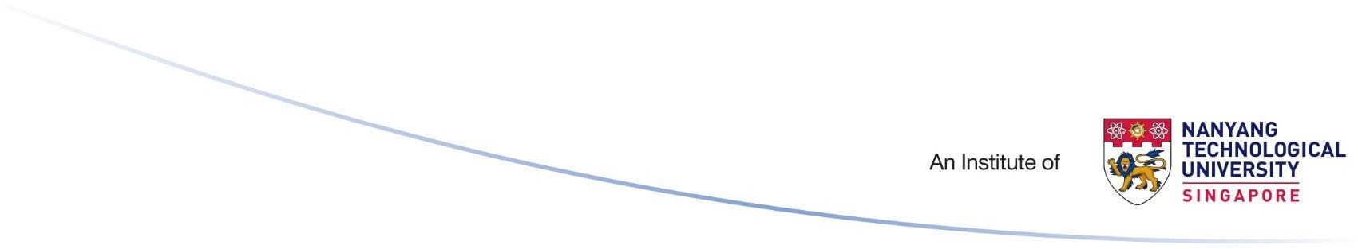
PTO
OAAS/14/2022

STUDENT SERVICES CENTRE
Block 1, Level 1

Lost and Found Report and Claim Form

For report of lost item, please email the completed form to: studentservices@nie.edu.sg. For found item, please bring the item to NIE Student Services Centre with a copy of this form duly completed.

Section 1: Particulars of Person Reporting
Full name : | Signature :
Contact Number : | Email Address :
Section 2: Details of Lost / Found Item
Date : | Description of Item:
Time :
Lost/Found Location (please circle accordingly) :
Section 3: Personal Data Protection
I understand, acknowledge, agree and consent that:
- National Institute of Education (NIE) is permitted to collect, use, disclose and/or process my personal data/personal information set out in this form and any other personal information provided by me or possessed by NIE for the purpose(s) of:

  - Processing, handling and/or dealing with this application

  - Carrying out and/or dealing with my instructions or responding to any enquiries by me

2

(iii) Contacting me or communicating with me via various modes of communication such as phone/voice call, text message and/or fax message, email and/or postal mail. I acknowledge and agree that such communication byNIE could be by way of the mailing of correspondence, documents or notices to me, which could involve disclosure of certain personal data about me to bring about delivery of the same as well as on the external cover of envelopes/mail packages

Acknowledged by Student

Name Signature Date
Section 4: Particulars of SSC staff who attended to the report of lost item or found item
Name : | Signature & Date:

Section 5 : Particulars of Person Claiming Item
Full Name : | Matric number/Last 4 alphanumeric characters of NRIC:
Contact Number : | Date & Time Claimed :

Updated _ April 2022

