We had a marvelous time at NIE/NTU’s Sustainability Learning Lab, discovering Singapore’s efforts to transform into a sustainable garden city. We learnt content related to Geography, Social Studies and Science, which enriched our curriculum learning as many of us take these subjects. It showed us how advanced and in-depth university education is. This gives us an idea of what we want to do in the future and what path we want to take in relation to our learning. We also learnt about the environment and climate change and it brought our attention to the importance of preserving our surroundings and nature, raising our awareness so that we can inform others about our current issues.

We think the people at the Sustainability Learning Labs, NIE, and NTU participate in very important work that contributes to the sustainable future of Singapore, such as investigating social problems like food waste and urban inequality and finding ways to reach out to educate the public, such as creating posters and infographics. We see these creations around the school compound, which helps us understand the environmental problems in our world. They also research scientific and geographical problems such as volcanoes and earthquakes and gave us a peek into their labs and their machines, where they explained their work to us. They also focus on social, economic and environmental aspects of the world and its issues, finding ways and methods to ensure a sustainable future such as editing the MOE syllabus and doing the best to play their part, such as during our Food and Society class where we used used orange peels to make detergent.
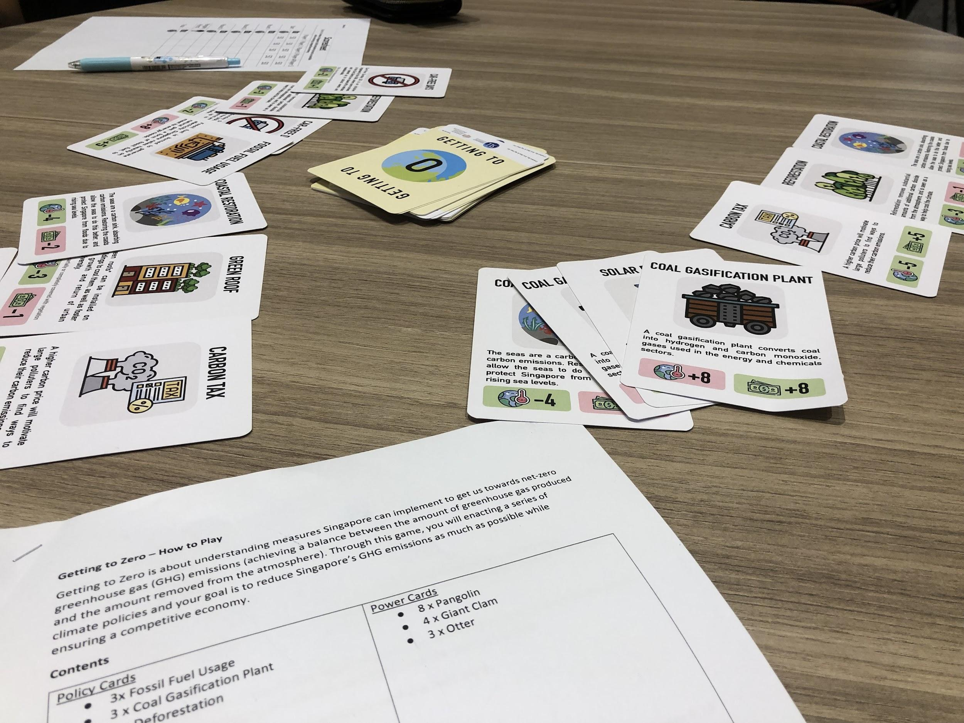
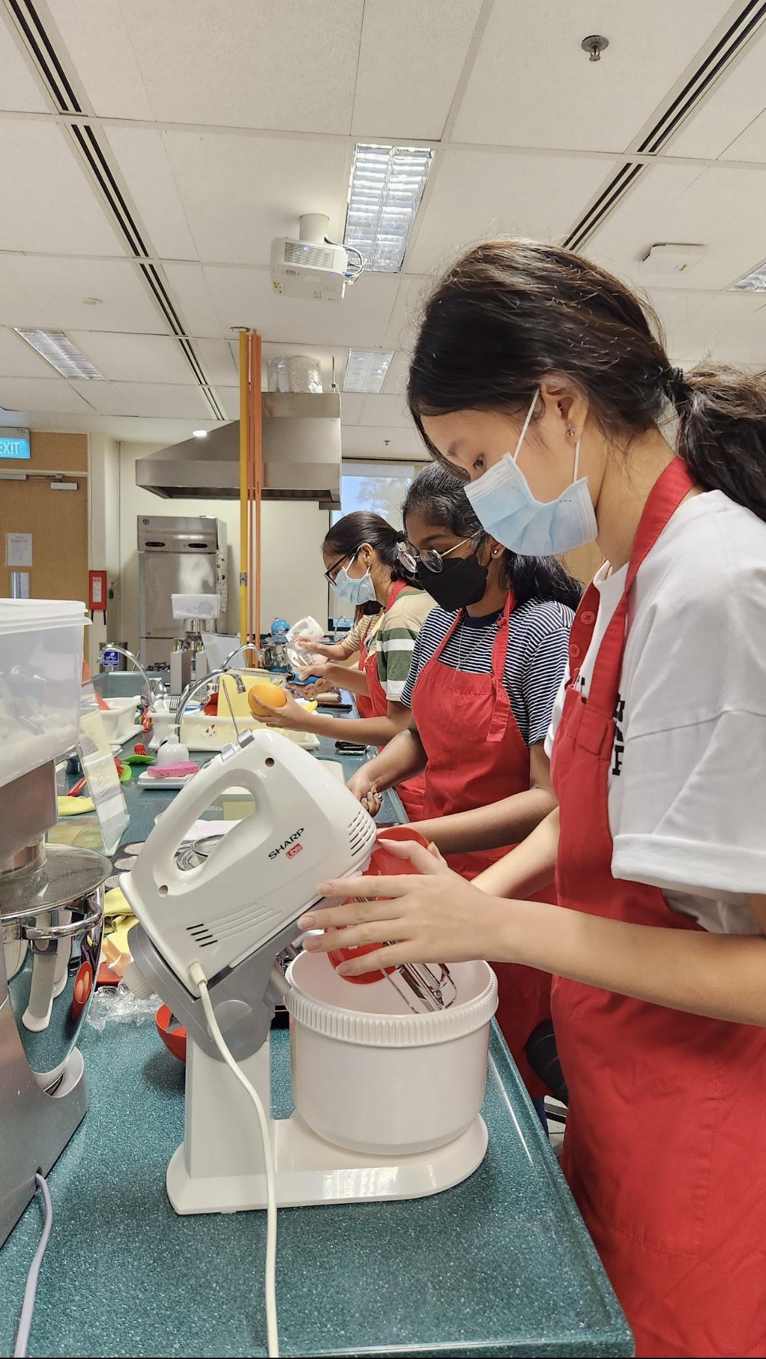
We find it inspiring to observe the passion of the researchers at the Sustainability Learning Lab, especially through the games that they created themselves. Their games were engaging and informative, and they managed to successfully incorporate games and education into something that is attractive to younger audiences. Some examples of the games we played were Getting To Zero (a card game) and Singapore Untamed (a board game). We enjoyed ourselves tremendously with these activities, and gained a deeper insight into the effects of sustainability on the economy, and the struggle that our wildlife faces due to our ambitions.

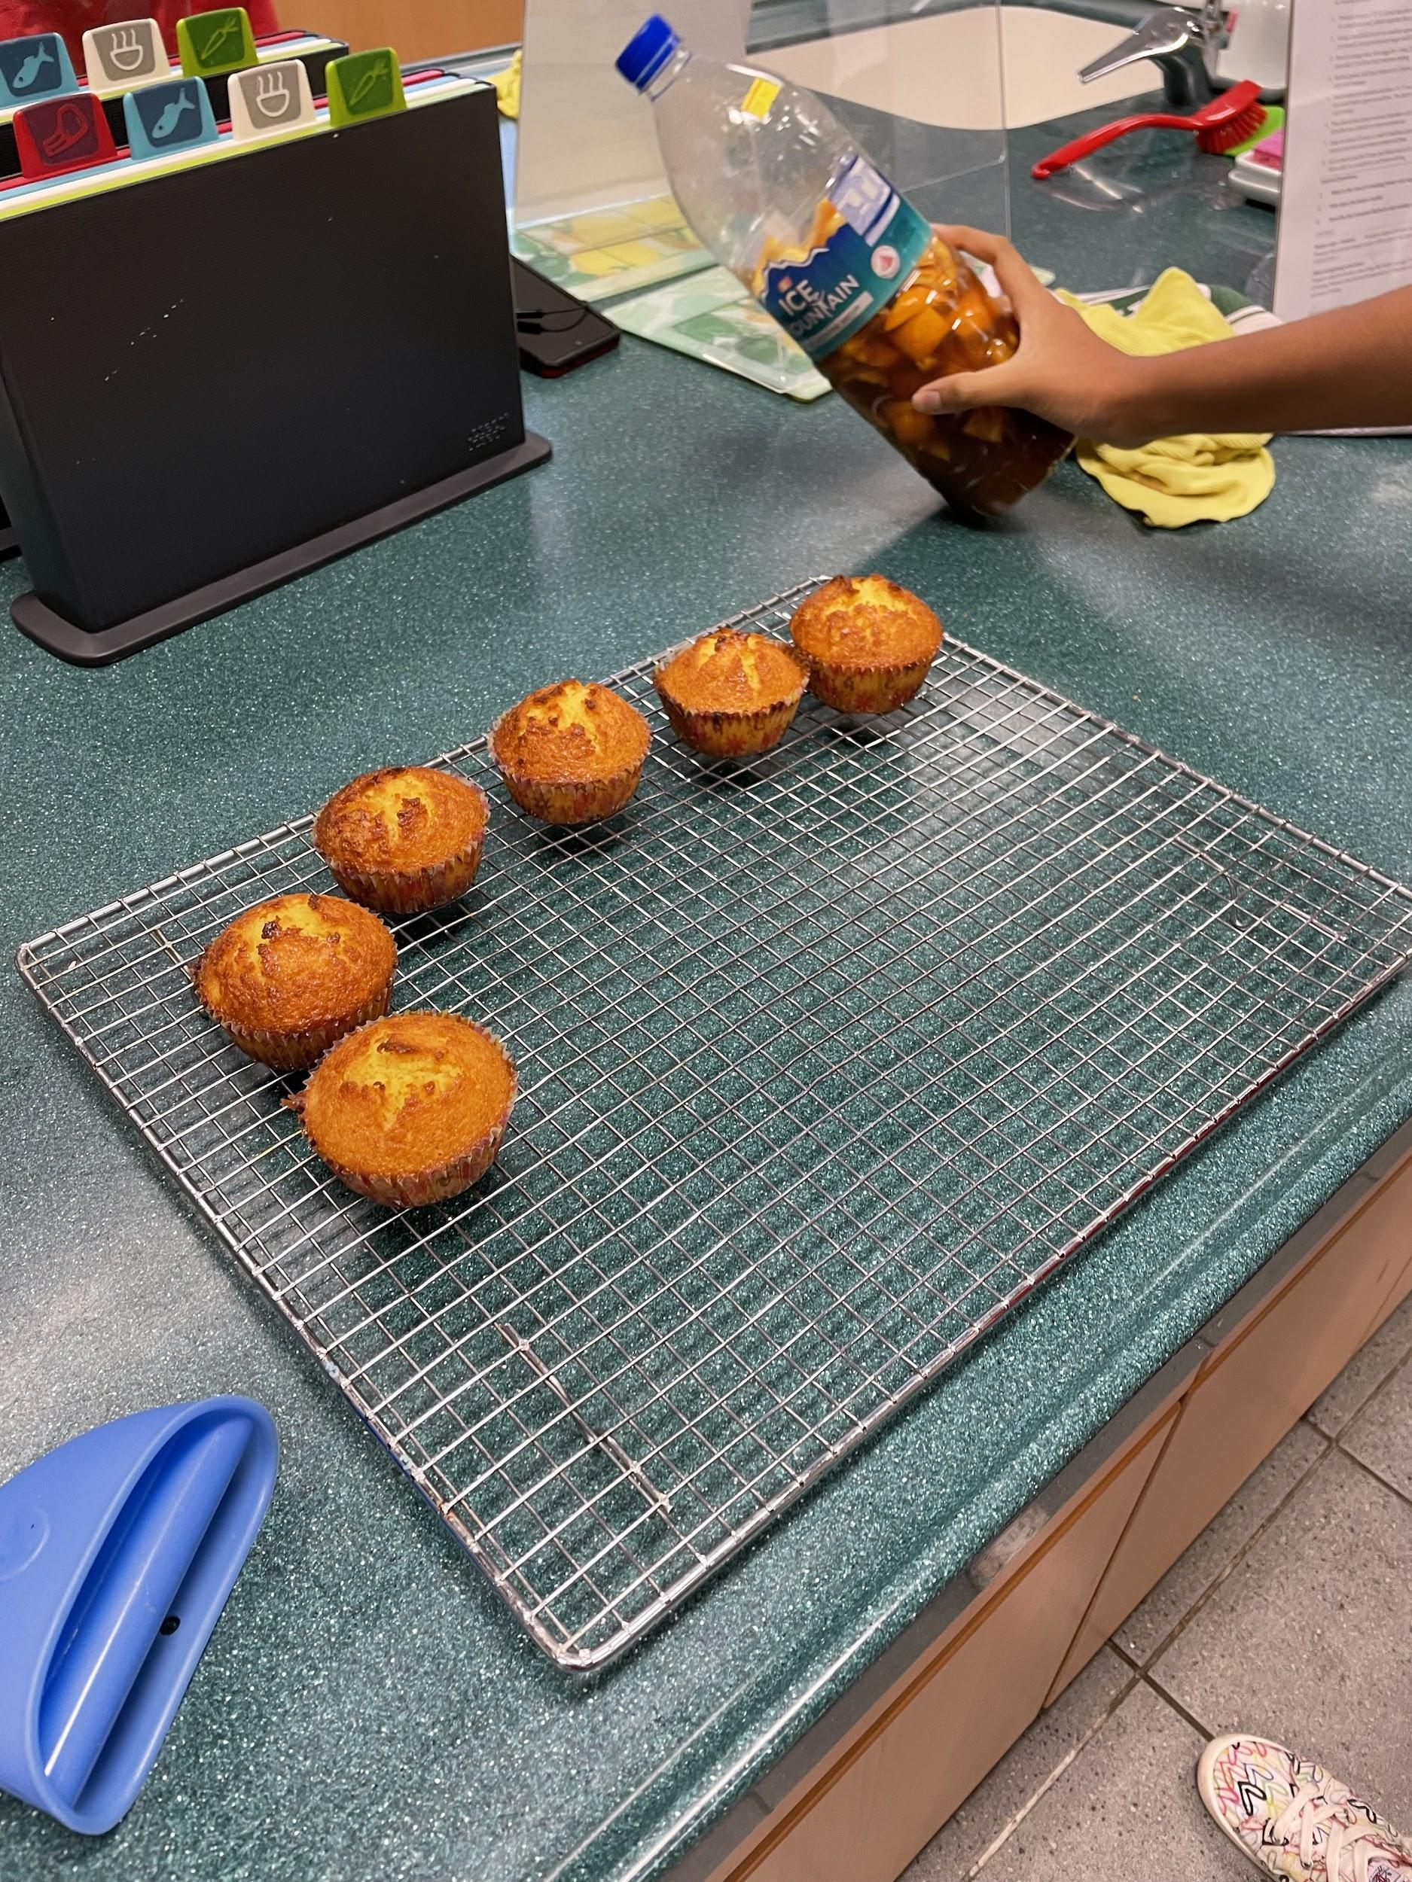
Another aspect that we explored was sustainability in the kitchen. We even got to participate in a hands-on activity by baking orange butter cakes and making an orange detergent, such that no part of the orange is wasted. This is an example of using ingredients sustainably and reducing food waste. We used the orange juice and zest for the cake, and the rinds for the detergent. It was an eye opening experience knowing that we could use parts of fruits and vegetables that are normally thrown away. We hope to apply this knowledge back home in our own kitchens!

We have a lot of takeaways from our three days at NIE, and we’ve come out of it with new knowledge of the dangers of climate change, and what we can do to contribute in the fight against it. Thank you to NIE for hosting us!
by: Megan, Shimin, Sakthi, Sanjana

